**IA Product Design Report**

Louis Zeng (lz406)

Fitzwilliam College, Group 94

* **Special product need**

The market needs cooling device which is at similar price range as ceiling fan while cover larger range while easier to install.

* **Problem statement**

Device has cooling effect to larger area than ceiling mounted cooling fans.

* **Design requirement**

1. Meet or exceed global HVAC (Heating, ventilation, and air conditioning) industry standards and applicable legislations.
   * + - 1. Meet ISO building environment standards ISO 16812:2006 which requires my design provide a healthy indoor environment for the occupants as well as protect environmental sustainability.
         2. United Kingdom CIBSE (The Chartered Institution of Building Services Engineers) provides guidelines for HVAC designs in the UK market, my design should aim to meet its requirements regarding energy efficiency.
       1. (Safety)Public health engineering: my design cannot contain prohibited material which can cause potential health risk. During normal operation, maintenance and repairing, my design should limit the potential harm caused to operator to minimum.
       2. (Materials)Sustainable design: reduce the usage of plastic in design, while using commonly recyclable high-density polyethylene construct plastic components. Package of the final product should also limit plastic and using recycled cupboard.
       3. (User friendly) Installation consideration: the design should available for slip-in or simple drilling installation. Installation process should be easy and swift to provide convenience for both installers and users.
       4. (Geometry) Design should be resistant to obstructions in normal households and office which may cause non-uniform airflow.
       5. (Durability) Resistant to high moisture or wet conditions and possible challenging weather conations, fiberglass reinforced plastic (FRP) may therefore be used.
       6. (Durability) Galvanized coating for endurance and durability. Steel components should be G-60 (for dry or low humidity) or G-90 (for damp or wet areas) coated galvanized.
       7. (Compatibility) Electrical power conserving requirements: power used by the devices should be reduced to minimal degree, produce economy benefit for the users. Adaptable to commercial 240V, three-phase power.
       8. (Costs) Unit cost < £200, less than twice of Honeywell HS1655E1 QuietSet Pedestal Fan.

10.(Costs) Development cost < £5,000

* **Overall and sub functions**
* **Solution Principles and Combinations**

|  |  |  |  |
| --- | --- | --- | --- |
| function | Solution principles | Solution principles | Solution principles |
| Easy installation & cheap | Integrated handle, castor wheels | Flat/wall hanging, copper brushless motor | Small size, no mount needed |
| Reliable mechanics | off the shelf components | bladeless | No moving parts |
| Energy efficient | Low power heat exchanger | No interruption on airflow | No electric motor |
| No hazardous coolant | HFC (Hydro Fluro Carbon) refrigerant | No heat exchanger | Water based coolant |
| Cover large area | Adjustable vent | Rotation head & Remote control | Individually handed out |

Combination 2

Combination 1

Combination 3

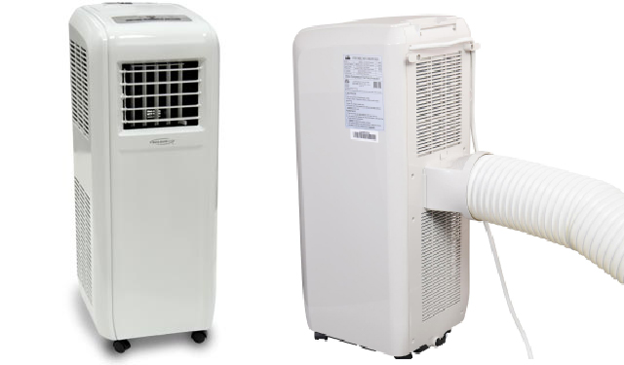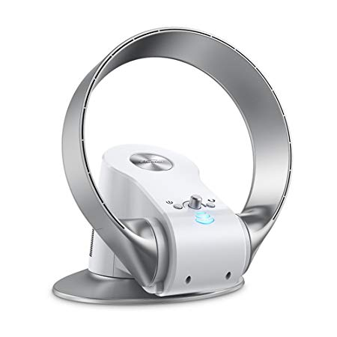

Reusable icepack can deliver and carried by each individual

Make current pedestal bladeless fan more flexible in mounting

Similar to low power portable AC unit

* **Concept evaluation**

Combination 2 is selected as the datum and the other 2 concepts are ranked against it using the following criteria:

1.Much better than the datum +2

2.Better than the datum +1

3.Same as datum 0

4.Worse than the datum -1

5. Much worse than the datum -2

|  |  |  |  |
| --- | --- | --- | --- |
| Criteria | Combination 1 | Combination 2 | Combination 3 |
| Cheap & cheerful | -2 | ---------------------- | +2 |
| Reliability | -1 | ---------------------- | +1 |
| Efficiency & eco-friendly | -1 | ---------------------- | -2 |
| Coverage Area | +1 | Datum | -2 |

**Conclusion**: Combination in junction of bladeless fan design is unmatched when judged by the junction of product economy, expected reliability, energy efficiency, carbon footprint and the most important initial design criteria: coverage area.

Combination 1 (portable AC unit) design loss point

* **Safety analysis**

**1. Mechanically Safe.** 40-watt electric motor sucks air in through small vents at the base, propelling air through the hollow, circular frame. No fast-spinning or moving blades, safe for children, and no need in cleaning the fan blades, minimises injuries caused by inappropriate operation, no safety grills which may fall apart after long period of usage.

**2. User safety.** Air is force through 1.3mm split in the frame at speed of 55mph. It travels over an aerofoil, which channels its direction. A smooth air flow is created by pushing the air forwards, dragging air from behind and from the sides. Therefore the airflow wouldn’t cause potential health risk or uncomforting

to pregnant women, the elderly. Dust are less likely be attached to the structure; health risk posed towards inhalation disease patients is limited.

Since the concept is devoid of external blades, it’s safer than a conventional ceiling fan or wall-mounted fan which does not come with safety cover, there is no fear for user in cutting by running blades.

**3.** **Fail safety** Meet IEC 60269 standard and British Standard BS1363 for low power fuse. Plugs for the design is rated up to 700 watts (20 times the motor working power), therefore a red coloured 3-amp fuse should be fitted with each plug, provides fail safety in case of the circuit overloads or there is a fault.

**4. Protection** Due to the devoid of blade structure, the design is significant lighter than a conventional ceiling fan. Thus the mounting is more durable both in case of ceiling and wall mount.

* **Stakeholder analysis**

The installation can be done by users or any technicians who is able to use an electric drill.

The cleansing of the fan can be dealt with by the users, the hollow tube doesn’t need special skills in terms of cleaning.

Control of the device can be responded by any adults through built in buttons or remote controller.

* **Diversity analysis**

Adopt the approach of reducing diversity and reduce sensitivity.

1. Fan size: approx. 31*36*27cm (L*W*H) for EU and USA

approx. 39*45*35cm for SE Asia and Africa

2. Instruction manual in English and main European languages.

3. Power plug adaptable to main output network voltages. (110- 240V)

* **Task analysis**

Necessary tasks must be conducted includes:

**1.Study** what’s the maximum distance regular users can feel about the cooling effect of the device. (Done by experiments in office condition).

**2.Study** what’s the power consumption under regular use in different voltage input. (Done by measurement while running the test unit)